Task on Docker-02
- Create a tomcat container on 8080 and deploy sample application in tomcat.
I have started the docker
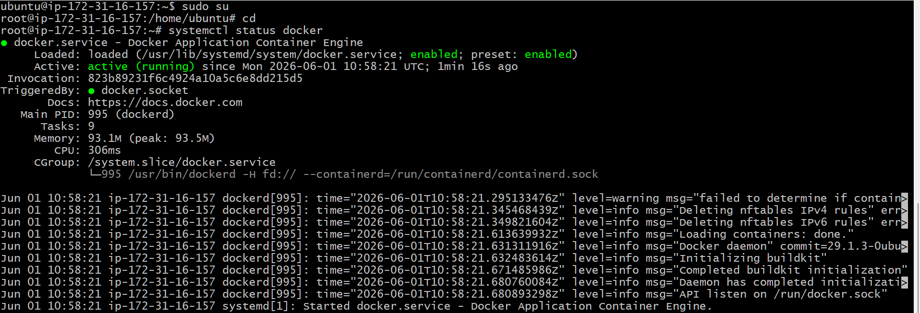
Pull Tomcat Image. Downloaded the Tomcat image
docker pull tomcat:latest
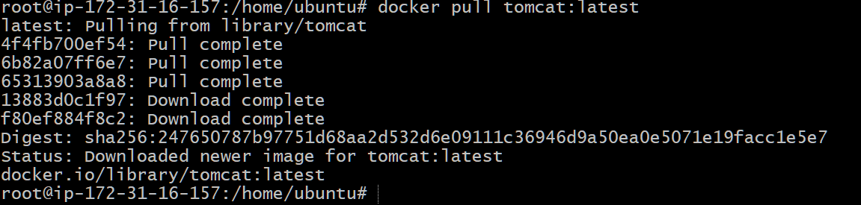
Verify docker images
docker images
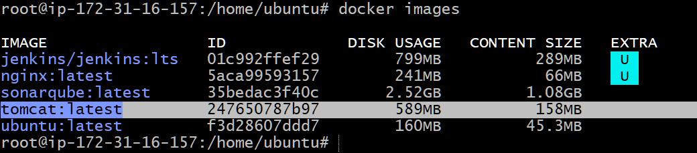
Create Tomcat Container and Run Tomcat on port 8080
docker run -d --name tomcat-server -p 8080:8080 tomcat:latest
Add verified Container is Running with: docker ps

Login to the running Tomcat container
docker exec -it tomcat-server bash
Navigate to the Tomcat deployment directory
cd /usr/local/tomcat/webapps
pwd
Update package repositories inside the container:
apt update
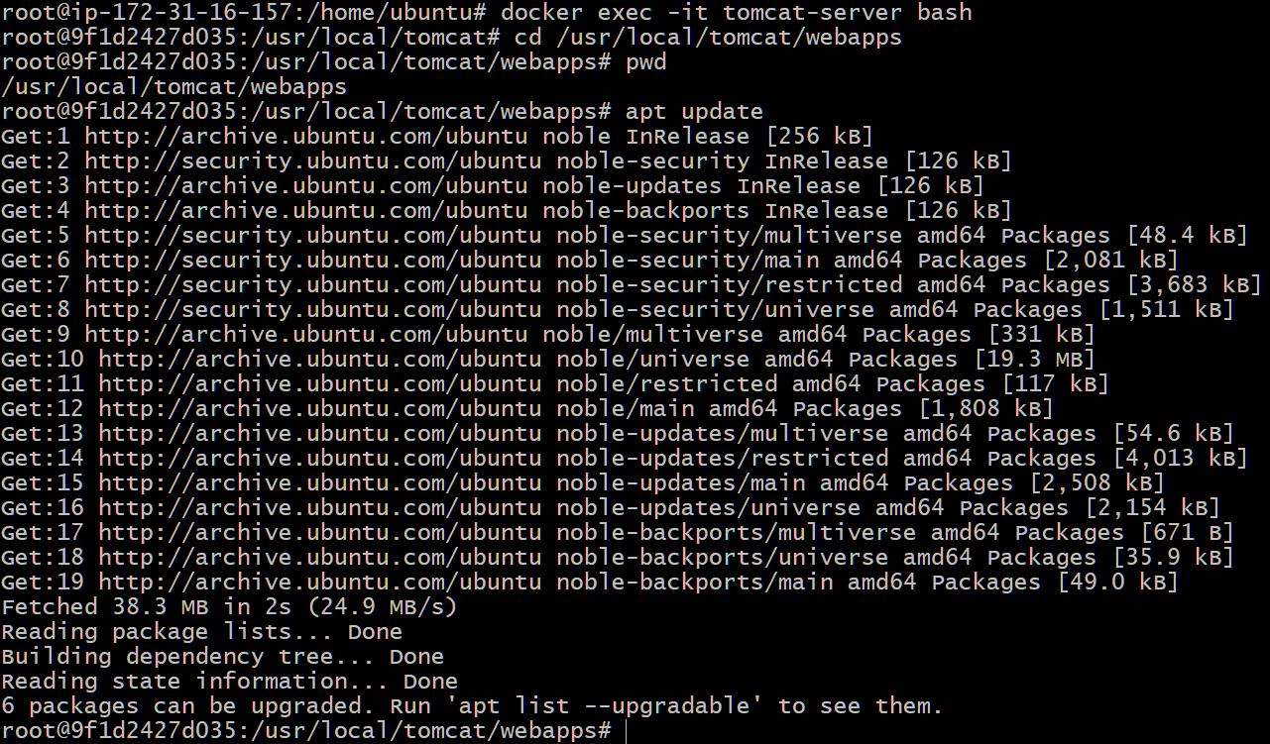
apt install wget -y
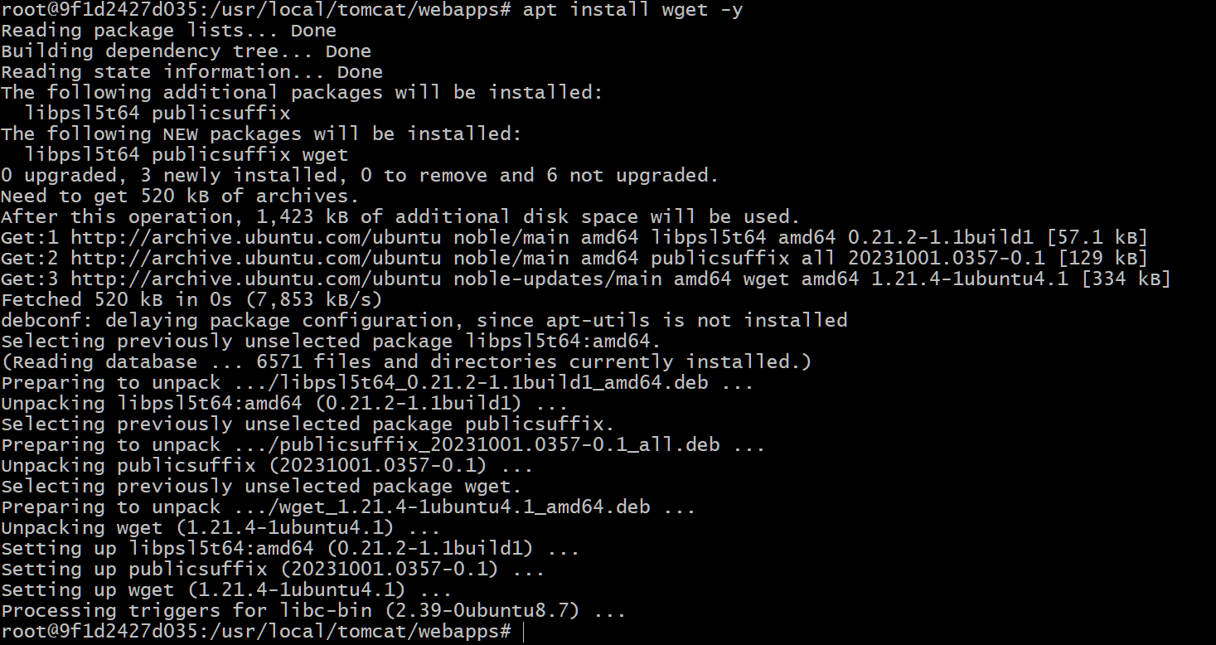
Download Sample WAR File
wget https://tomcat.apache.org/tomcat-7.0-doc/appdev/sample/sample.war
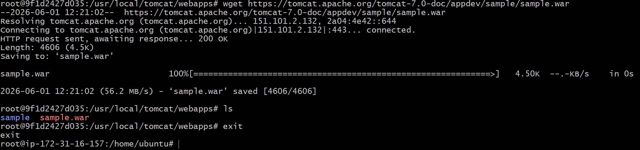
verify Application Deployment Using Docker Logs
docker logs tomcat-server
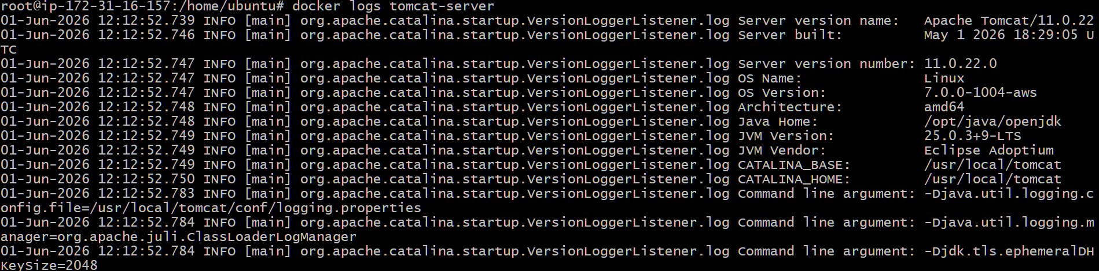
docker ps
docker exec -it tomcat-server bash
cd /usr/local/tomcat/webapps
ls -lrt
exit
curl -I http://localhost:8080/sample
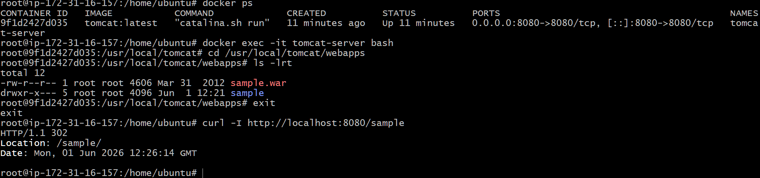
Successfully created a Tomcat Docker container on port 8080, deployed the sample.war application.
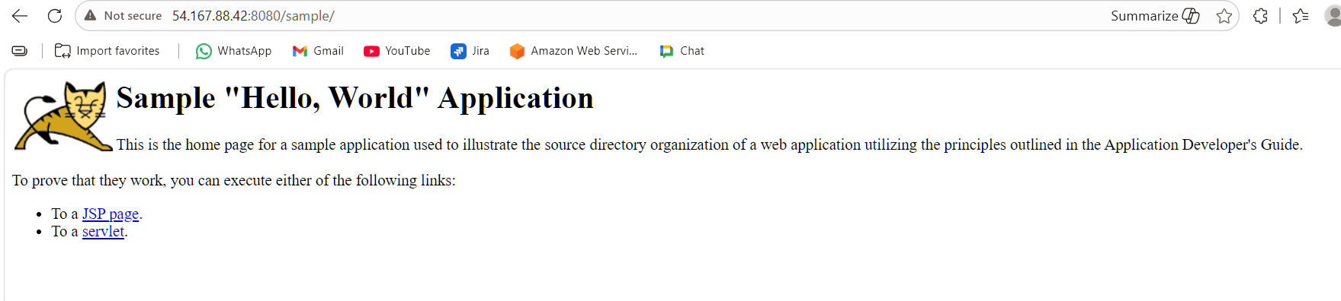
- Create volume and deploy tomcat container on port 8081.
Created a volume
docker volume create tomcat-volume
docker volume ls
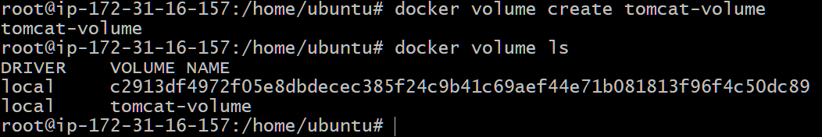
-d → Run in background
--name tomcat-8081 → Container name
-p 8081:8080 → Host port 8081 mapped to container port 8080
-v tomcat-volume:/usr/local/tomcat/webapps → Mount volume to Tomcat webapps directory
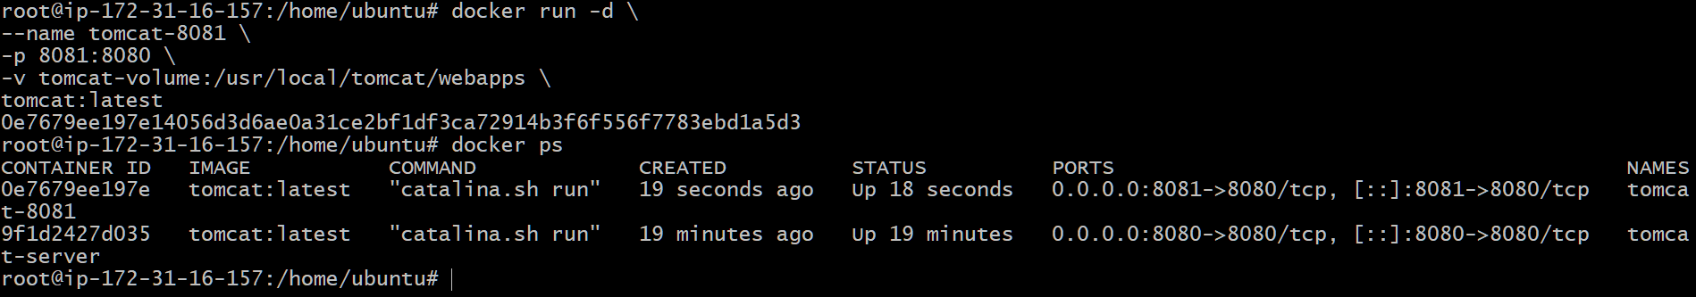
Verify Volume Mount
docker inspect tomcat-8081
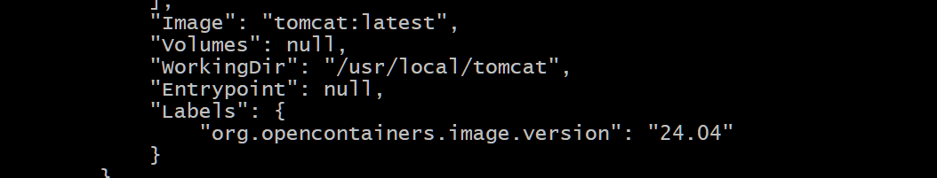
Login to container
docker exec -it tomcat-8081 bash
cd /usr/local/tomcat/webapps
ls -ltr
pwd
apt update
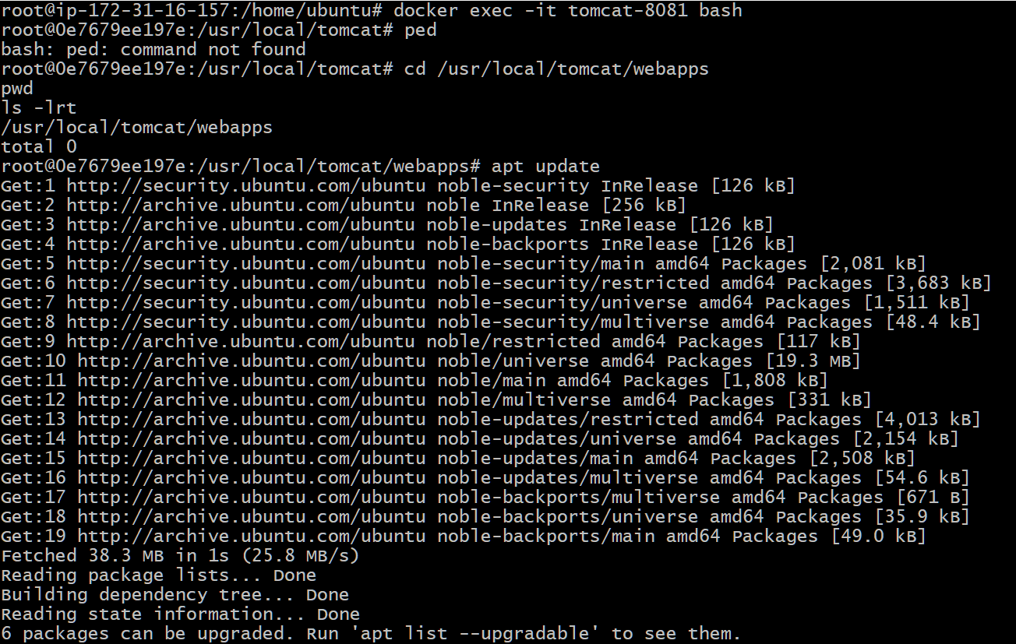
apt install wget -y
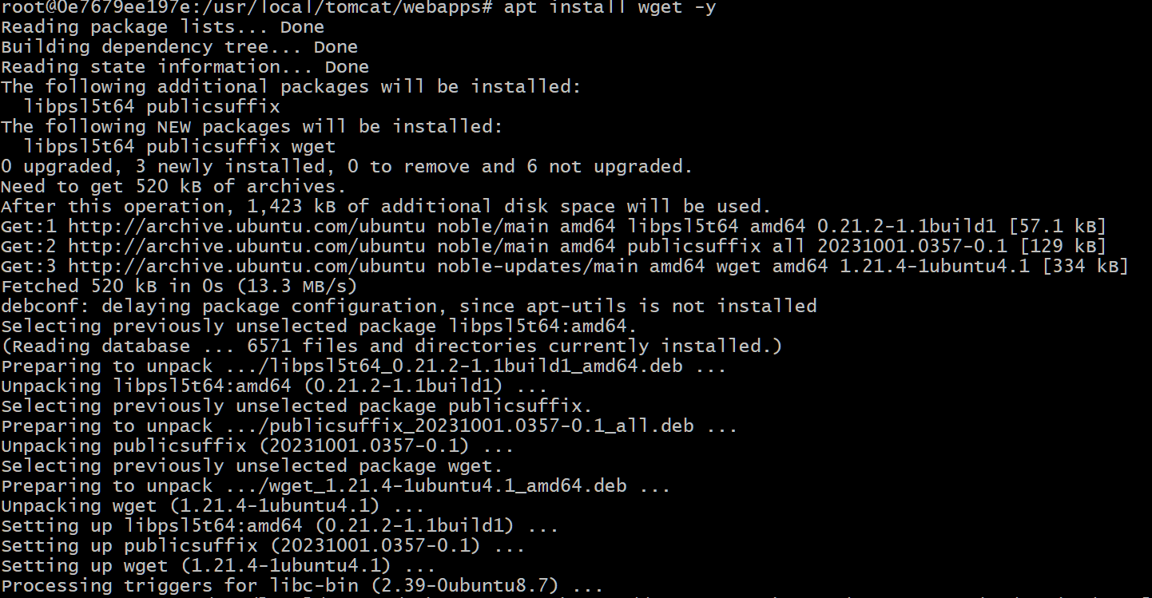
wget https://tomcat.apache.org/tomcat-7.0-doc/appdev/sample/sample.war
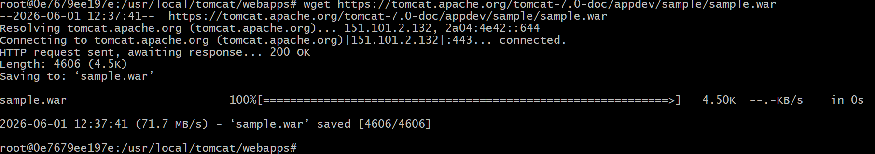
Move WAR file to webapps:
mv sample.war /usr/local/tomcat/webapps/
Verify: ls -lrt /usr/local/tomcat/webapps
exit
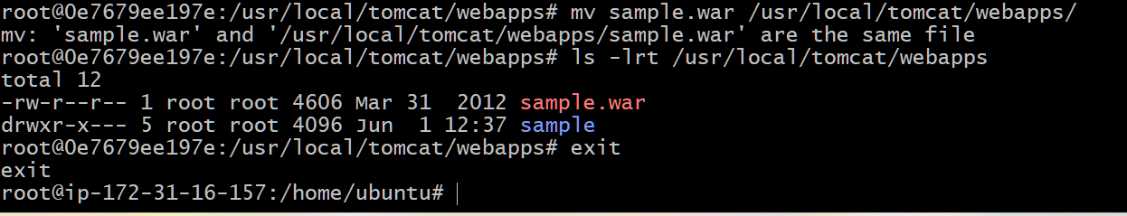
Checked the logs
docker logs tomcat-8081
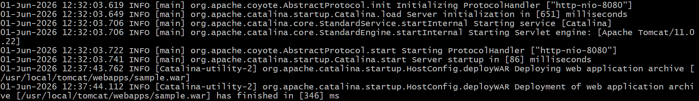
Verify Deployment
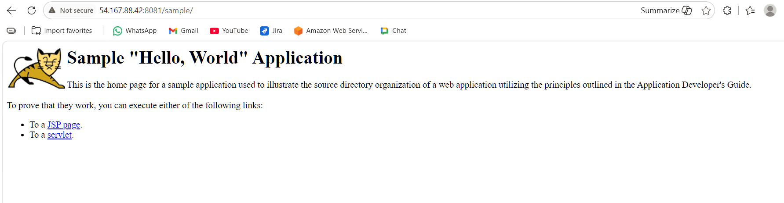
- Limit the nginx container to 500 MB.
Pull Nginx image
Docker pull nginx:latest
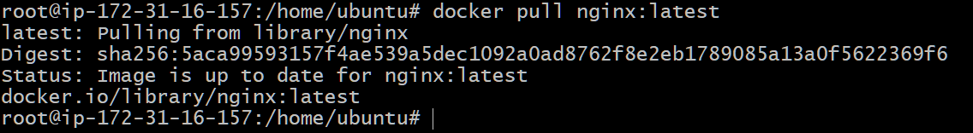
Run Nginx Container with 500 MB Memory Limit
docker run -d → Run in detached mode
--name nginx-500mb → Container name
-p 80:80 → Map host port 80 to container port 80
--memory="500m" → Limit container memory to 500 MB
nginx:latest
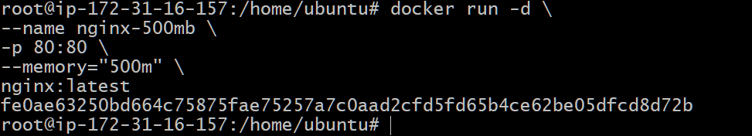
Verify Container is Running
docker ps
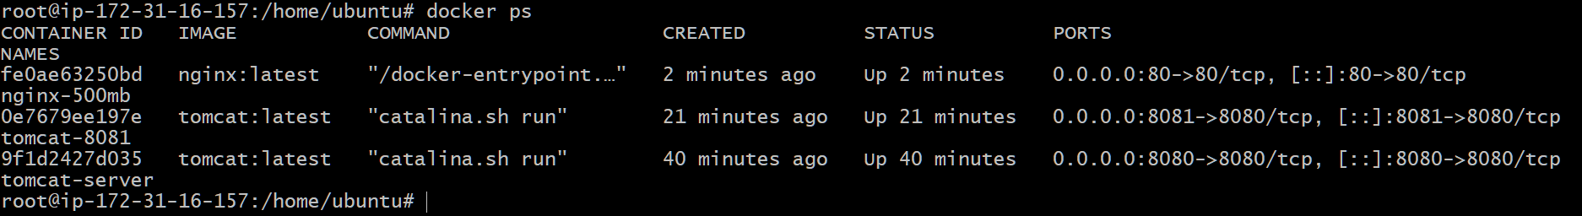
Verify Memory Limit
docker inspect nginx-500mb
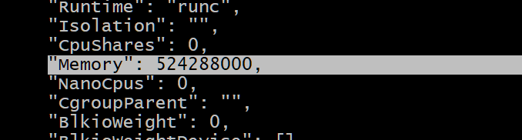
docker stats nginx-500mb
Verify Nginx
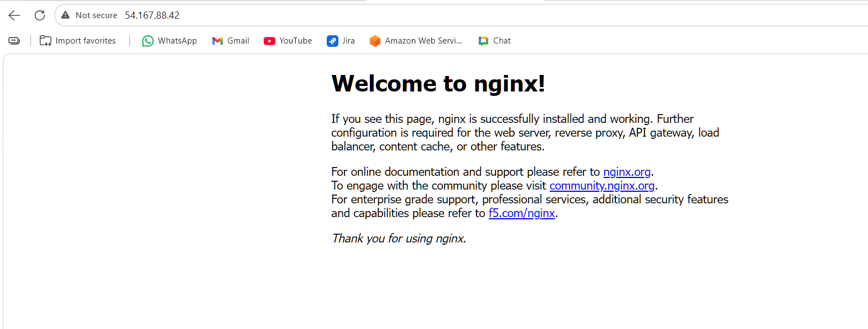

- Create a sample docker file using below instructions.
  - Base module as amazonlinux:latest
  - Maintainer you name
  - Install nginx
  - COPY one index.html file to image
  - Expose on port 80
  - Command to start the nginx container
Create a working directory
mkdir nginx-docker
cd ngnix-docker
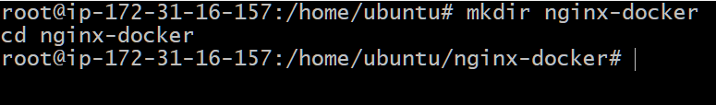
Create index.html
vi index.html
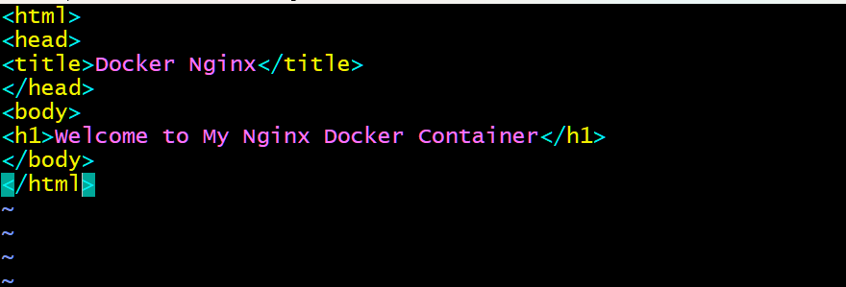
Create Dockerfile
vi Dockerfile
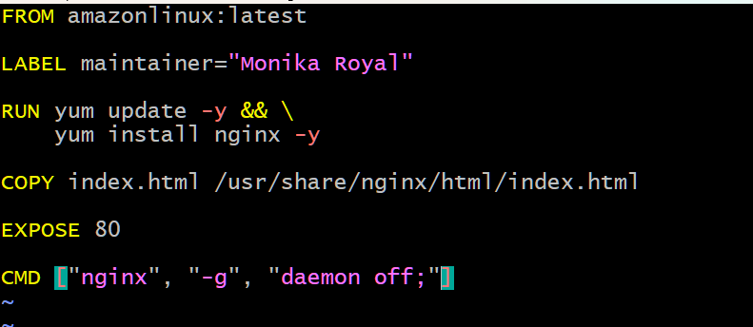
Build the image
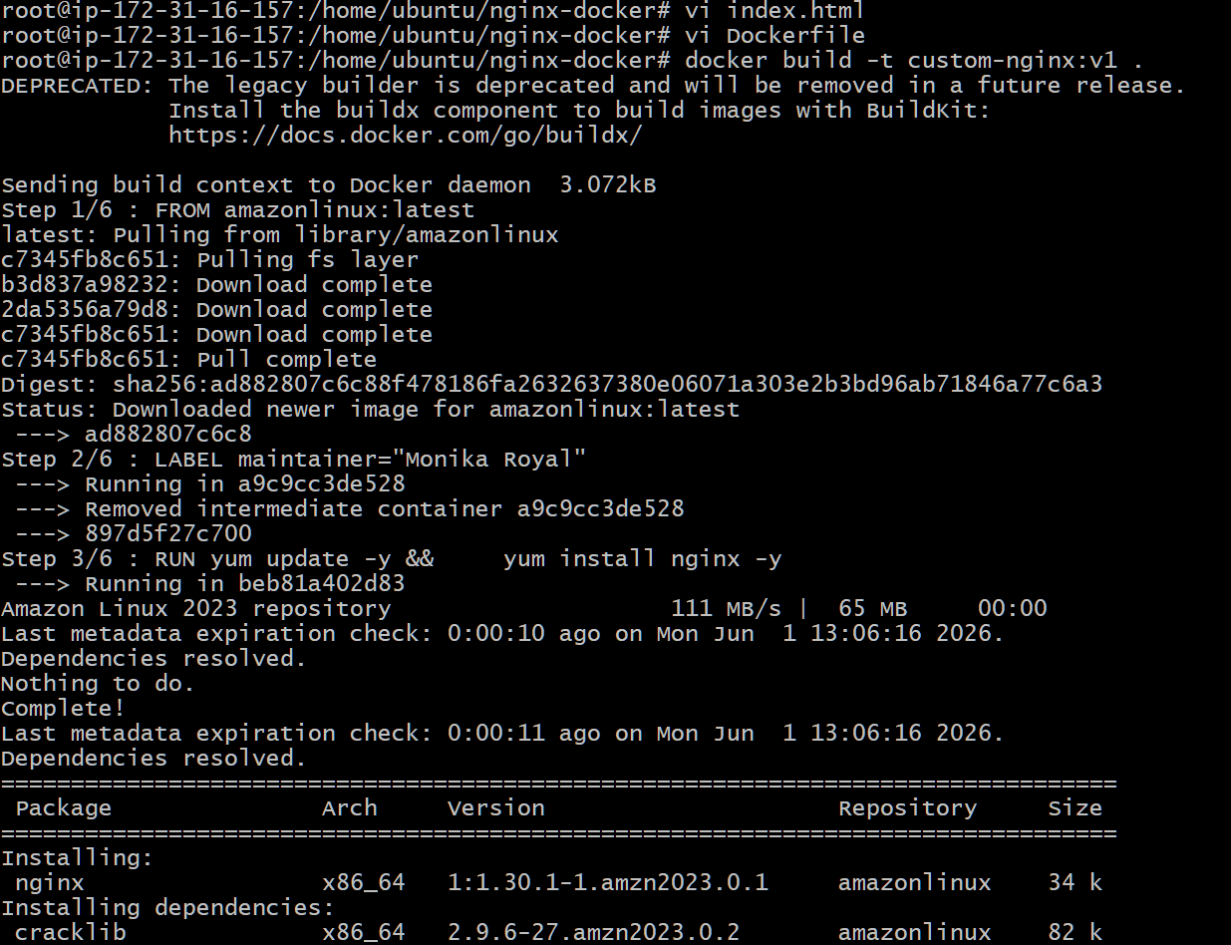
Docker images
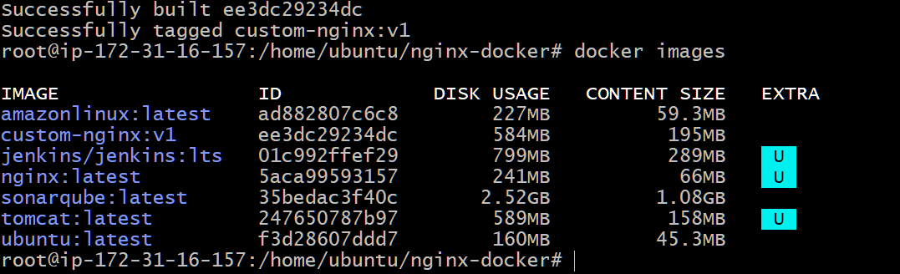
docker run -d --name nginx-custom -p 8080:80 custom-nginx:v1
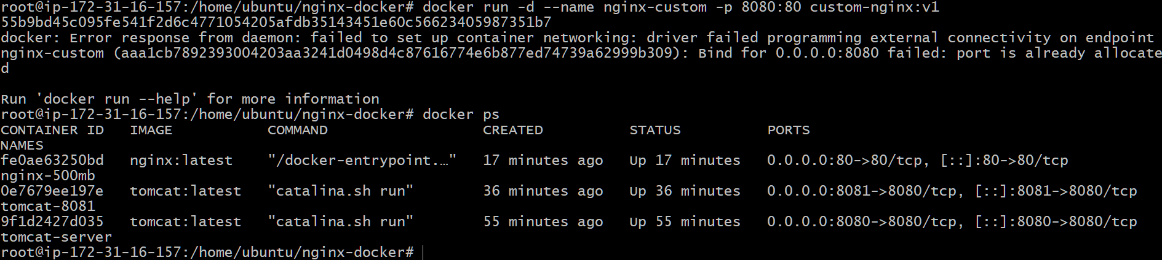
Verify
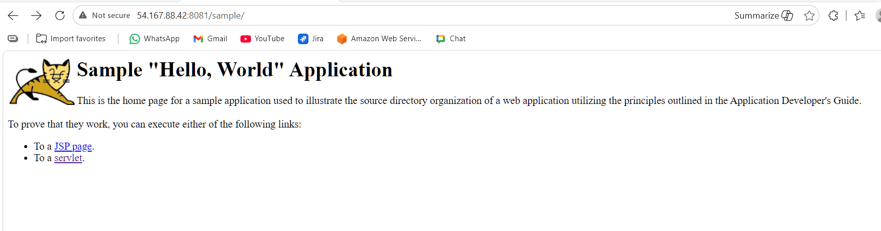
FROM amazonlinux:latest → Uses Amazon Linux as the base image.
LABEL maintainer="Monika Royal" → Specifies the image maintainer.
RUN yum install nginx -y → Installs Nginx.
COPY index.html → Copies the web page into the image.
EXPOSE 80 → Documents that the container listens on port 80.
CMD ["nginx", "-g", "daemon off;"] → Starts Nginx in the foreground when the container runs.
- Push image to Docker hub
Verify images
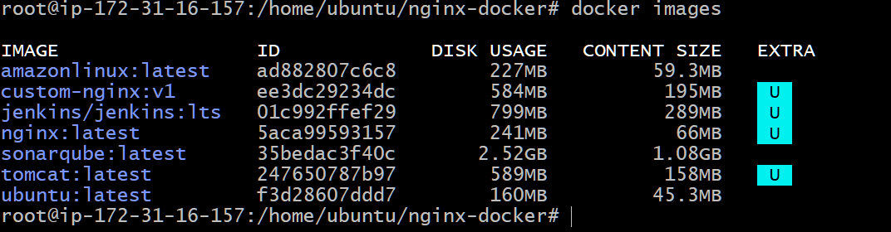
Username: monikaroyal19
Password: Monika@19

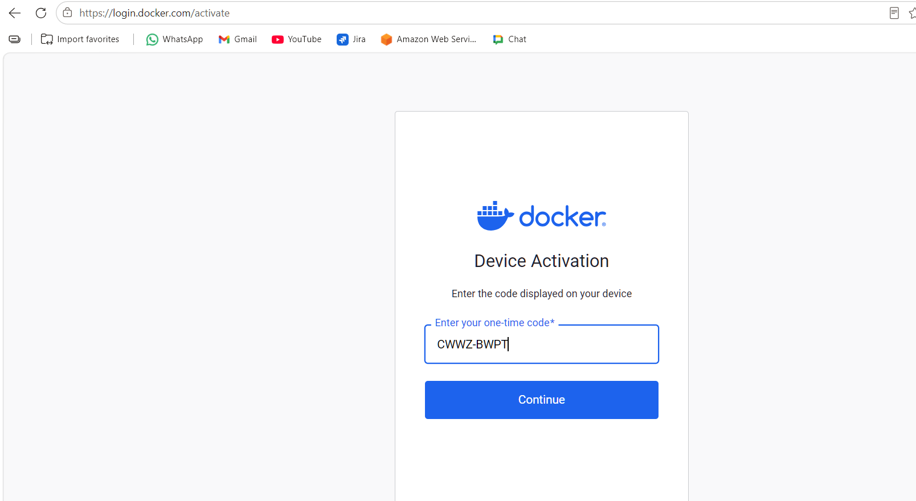
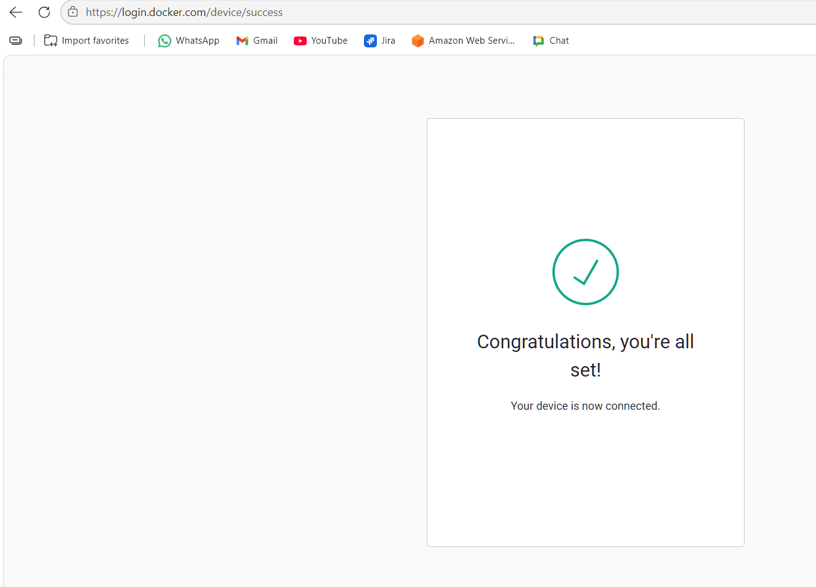
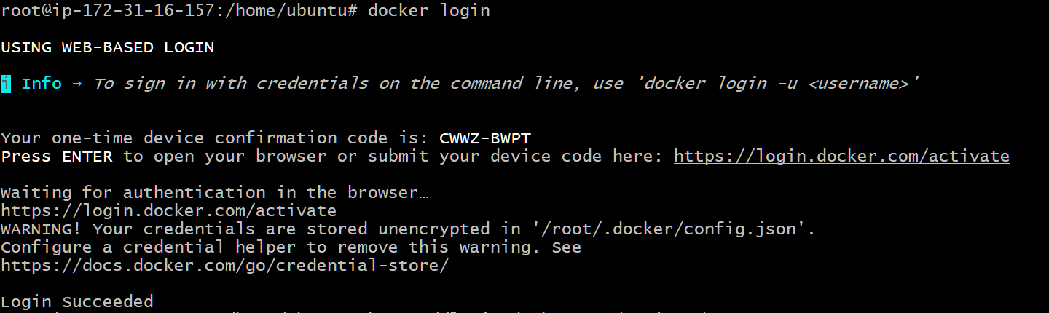
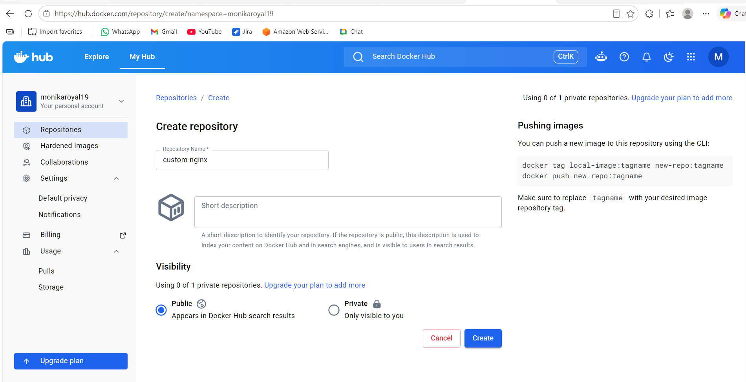
Created the image
docker tag custom-nginx:v1 monikaroyal19/custom-nginx:v1
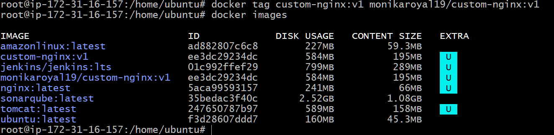
docker push monikaroyal19/custom-nginx:v1
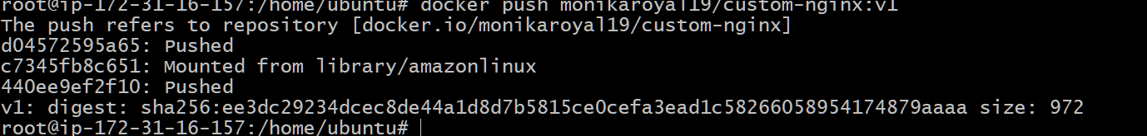
Verify the Image in Docker Hub
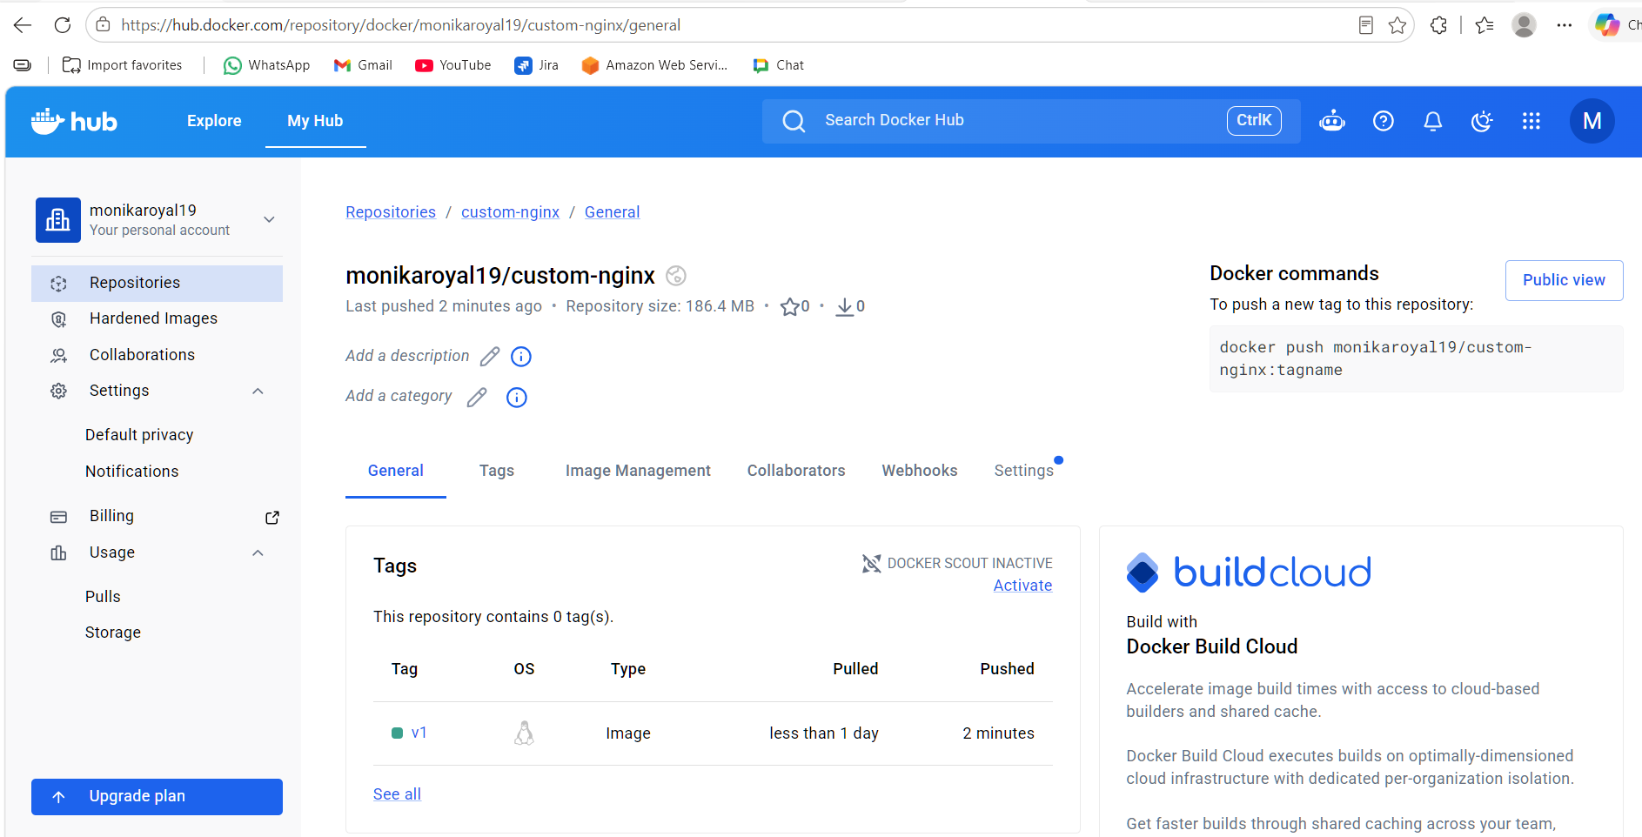
- push image to AWS ECR
sudo apt update
sudo apt install awscli -y
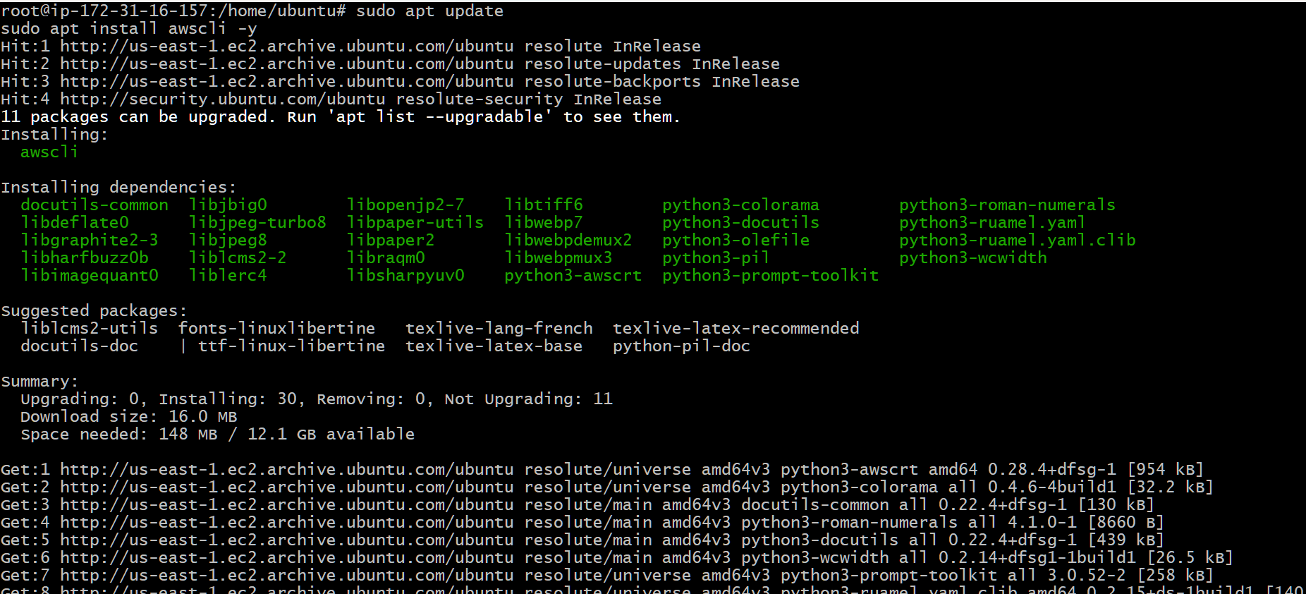
aws –version
aws configure and Verify Configuration
aws sts get-caller-identity
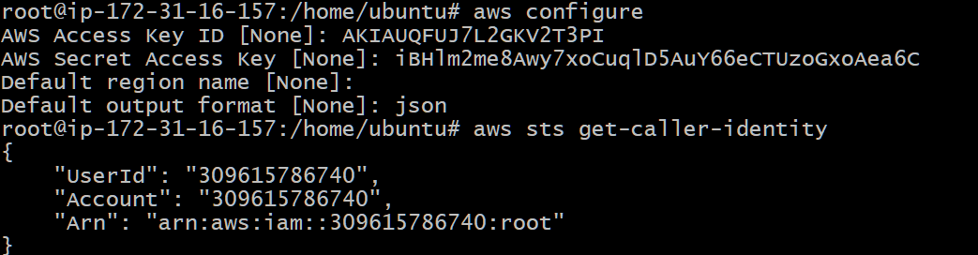
Login to AWS ECR
aws ecr get-login-password --region us-east-1 | docker login --username AWS --password-stdin 309615786740.dkr.ecr.us-east-1.amazonaws.com
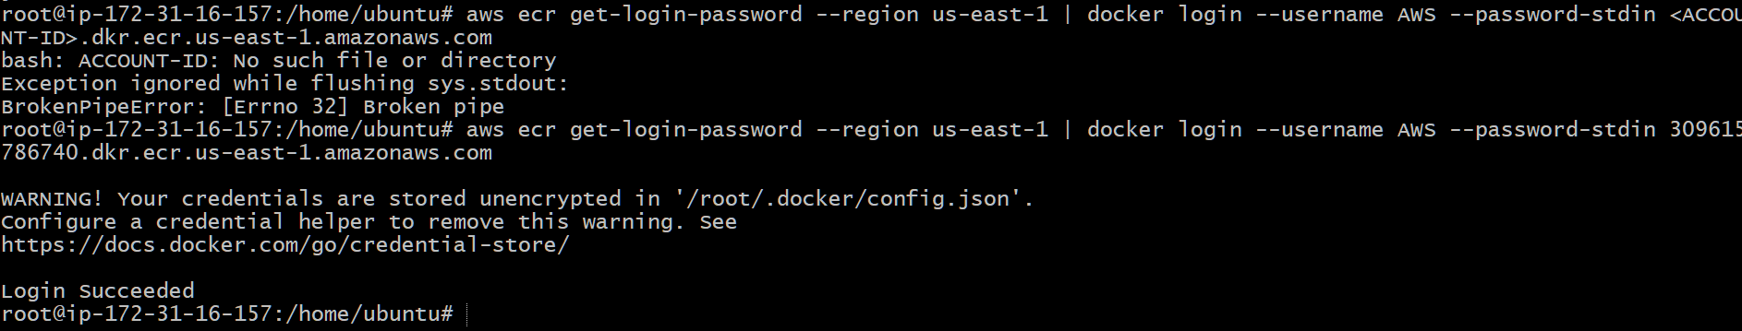
aws ecr create-repository --repository-name custom-nginx
docker tag custom-nginx:v1 309615786740.dkr.ecr.us-east-1 .amazonaws .com/custom-nginx:v1
docker images
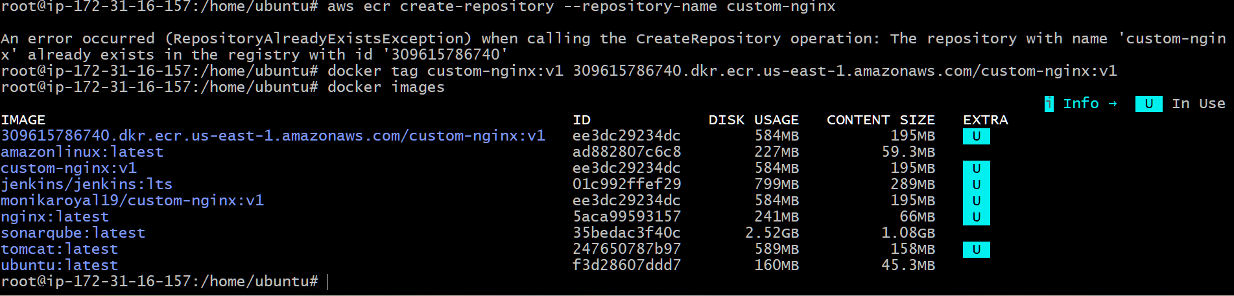
Push the image
docker push 309615786740.dkr.ecr.us-east-1.amazonaws.com/custom-nginx:v1
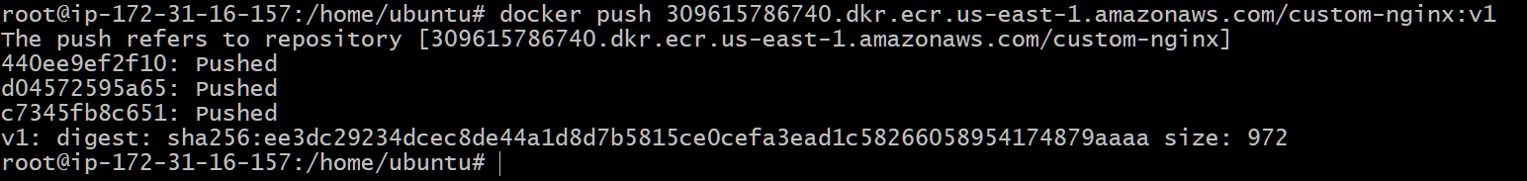
Checked in aws console
Login to AWS Management Console In the search bar, type: ECR Click Elastic Container Registry Click Repositories on the left side Open the repository: custom-nginxClick on the repository name.
You should see something like:

